NY-DEx Use and Dissemination

As contributors to the New York Data Exchange (NY-DEx), your agency may designate users to access the FBI’s National Data Exchange (N-DEx) Search system via the eJusticeNY Integrated Justice Portal in order to search and view the data contributed to both the NY-DEx and N-DEx systems to be used for investigative analysis purposes.

Users designated to access the N-DEx system must complete or have completed the CJIS Certification test. Users must also comply with the instructions in the attached N-DEx Policy and Operating Manual. Training should be provided to your users and it may include the below referenced N-DEx Online training modules tailored to N-DEx System Roles.

CJA Executive – Management (Chiefs, Sheriffs, Captains, Lieutenants)
- User Overview (30 minutes)
- Initiating System Policies (30 minutes)
- NDEx Police and Operating CBT (30 minutes)
Agency Investigator/Analyst (Investigative Specialists, Detectives, Deputies, Patrol Officers, Crime Analysts, Intel Specialists)
- User Overview (30 minutes)
- NDEx Policy and Operating CBT (30 minutes)
- Search (30 minutes)
- Visualization (30 minutes)
- Subscription and Notification (30 minutes)
- Collaboration (30 minutes)
Agency Source Data and Security Administrators (RMS Personnel, Local Data Administrators)
- User Overview (30 minutes)
- NDEx Policy and Operating CBT (30 minutes)
- Data Management (45 minutes)
- Data Sharing (45 minutes)
- Administrative Roles (30 minutes)

These training modules can be found on the N-DEx interface in the upper right hand side of the main screen by click on “Training”:
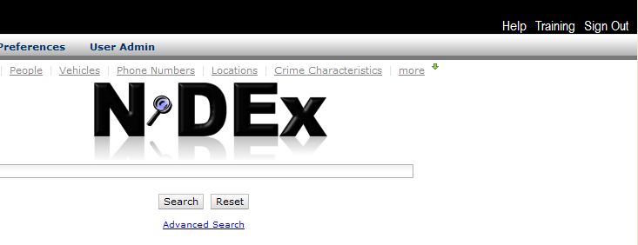

**It is important to recognize system access will be audited. Before accessing the system you will be prompted to acknowledge and accept the following conditions:

Terms of Usage and Acknowledgement

“Release of any of the information presented in NY-DEx to unauthorized individuals or agencies is prohibited.

This information is to be used for investigative analysis purposes only. Destroy after use and conduct an updated search for subsequent needs. All information presented herein is as complete as the data furnished to DCJS.”

N-DEx Terms of Usage Acknowledgement
“N-DEx is an official United States Government system for use only by authorized members of the law enforcement, criminal justice, homeland security, and national security communities. Information made available through N-DEx is considered to be "sensitive but unclassified" and is for official law enforcement/criminal justice/homeland security/national security use only. N-DEx use will be monitored and recorded for security and administration purposes. By clicking on the "I Agree" button below, you are agreeing to comply with the terms stated in this N-DEx Terms of Usage Acknowledgement, knowing that monitoring is being performed, consenting to such monitoring, and recognizing that you have no reasonable expectation of privacy while using N-DEx. Unauthorized access of N-DEx or unauthorized use of the information provided by N-DEx is prohibited and may subject you to administrative, civil, and criminal action. Anyone using N-DEx expressly consents to such monitoring and is advised that if such monitoring reveals evidence of possible abuse or criminal activity, system personnel may provide the results of such monitoring to appropriate officials.
Each contributing agency/entity retains sole ownership of and sole responsibility for the information made available via the N-DEx system. Therefore, each contributing agency/entity will have an obligation to maintain system discipline which includes the timeliness, completeness, and accuracy of the data made available via the system.
N-DEx information may not be used as a basis for any action, unless permission from the contributing agency/entity (owner of the record) is obtained. Accordingly, N-DEx information may not be incorporated into an official investigative or case file, used for any official action (e.g. affidavits, warrants, or subpoenas), or disseminated without such permission.
Immediate dissemination of N-DEx information can be made without the permission of the contributing agency/entity only if: (a) there is an actual or potential threat of terrorism, immediate danger of death or serious physical injury to any person, or imminent harm to public safety, homeland and/or national security; and (b) it is necessary to disseminate such information without delay to any appropriate recipient for the purpose of preventing or responding to such threat. The contributing agency/entity (owner of the record) shall be immediately notified orally and in writing of any dissemination made under this exception.
N-DEx system users agree to comply with the Criminal Justice Information Services Division's Security Policy, as well as, all established N-DEx policies.
Using publicly accessible computers (e.g. libraries, airports, cafes, hotels, etc.) to access N-DEx is unauthorized. This type of usage may result in the involuntary dissemination of information to unauthorized entities. Data may be left on this computer resulting in the next person using this machine the ability to view your data.
N-DEx is designed to work with Firefox 3.x, Internet Explorer 7.x, and Internet Explorer 8.x browsers.
I hereby acknowledge that I am fully aware, understand, and agree to the terms contained within this N-DEx Terms of Usage Acknowledgement.”
To designate users from your agency please provide the user’s name, agency, ORI and email on page 4. If a user has already been provided an eJusticeNY Integrated Justice Portal account, please note the IJ Portal UID. Please leave this field blank if this is a new IJ Portal account request.

**Please note this document and the policies herein are subject to change as the eJusticeNY Integrated Justice Portal Use and Dissemination and auditing language is formalized.

User Request Form

Name | Agency | ORI | Email | IJ Portal UID

