DCJS’s upgrade to the Spectrum Justice System’s (SJS) backup utility for Oracle 11 G Express users only. By Jeff Ellman NYSITS DCJS SJS ITS2P

Disclaimer: DCJS is not responsible for an agencies backup and recovery disaster plan or maintenance of their computer systems. This backup utility update is offered as a tool to assist SJS users in securing viable backup. You are free to enhance it as needed at your own risk.

Release notes:
- Implement time control for preventing file corruption
- Implement file comparison for preventing file corruption
- Implement archiving
- Implement backup and archiving retention
- Implement new naming convention for backup directories: YYYYMMDDHHMMSS
- The utilities root directory and the backup/archive directories will now contain two new log files
  - sjs_coldbackup11xe.log
    - Logging of events
  - compare.log
    - Logging of file comparisons of production database files to backup database files
- Steps to recover from backup.

Outline
- Deploy
- Configure
  - Location Options
- Backup and recovery

- Deploy

- Download the self-extracting zip file and extract to the root of the SJS installation drive; change the drive letter in the “Unzip to folder” as needed to reflect your SJS installation.

http://www.criminaljustice.ny.gov/ojis/sjs/sjs70.htm
- SJS_ColdBackup11xe.exe
- Click “Unzip”:
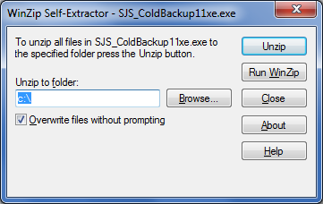

- Enter password obtained from DCJS and click “OK”:
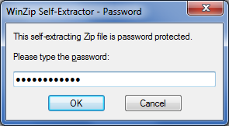
- Click “OK”:
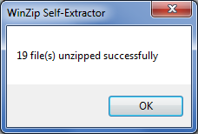
- In this example the following directory structure would have been extracted to your C drive:

- Configure

- To configure you need to edit the file: \ SJS_ColdBackup11xe \sjs_coldbackup11xe.bat
  - To edit right click on select “Edit”.

Perform the following edits:
- Set the Backup retention value to specify how many days to keep a backup:
  - Edit the value assigned on line 7:
    - set retain_backup=7
- Set the Archive retention value to specify how many days to keep an archived backup:
  - Edit the value assigned on line 8:
    - set retain_archive=14
      - In this example, this value will keep 7 days of backups in the archive location for seven days will have passed before being moved from the backup directory.
- Set the correct drive letter for your SJS’s Oracle installation:
  - Edit the value on line 9:
    - set sjs_drive=c:\
- Next, choose either a local, mapped, or network location for your backup and archiving locations. There are two options:
  - Backup Location Option 1: Local Drive or Mapped Network Drive
  - Backup Location Option 2: UNC paths

- Location Option 1: Local Drive or Mapped Network Drive
  - If using the default settings for the local drive option, create at the following folder structure as depicted on 17-18
    - Line 17: set backup_location=%util_folder%backups
      - Create folder “backups” at: C:\SJS_ColdBackup11xe\backups
    - Line 18: archive_location=%util_folder%archives
      - Create folder “archives” at: C:\SJS_ColdBackup11xe\archives
  - If you using a mapped drive, edit line’s 17 and 18 to reflect the examples in lines 20-21; or comment lines 17 and 18 and uncomment lines 20-21 and update to reflect your mapped drive (a comment is the command “rem” (without quotes)- add and remove as needed. Ex from above; what’s highlighted is what you need to edit to reflect your SJS:
    - Line 17: rem set backup_location=%util_folder%backups
    - Line 18: rem set archive_location=%util_folder%archives
    - Line 20: set backup_location=Y:\test\backups
    - Line 21: set archive_location=Y:\test\archives
  - Go to the steps for “Scheduled Task”
- Location Option 2: UNC paths
  - Comment out lines 17 and 18 under “Option 1” by adding “rem”:
    - Line 17: rem set backup_location=%util_folder%backups
    - Line 18: rem set archive_location=%util_folder%archives
  - Uncomment lines 26-27 by removing “rem” and editing to reflect your UNC Path as highlighted below:
    - Line 26: set backup_location=\\pvwap22\sjsdata\test\backups
    - Line 27: set archive_location=\\pvwap22\sjsdata\test\archives
  - Add the comment “rem” to lines 65 through 68, used with Option 1, exampled below:
    - Line 65: rem (
    - Line 66: rem %util_tool%forfiles /p %backup_location% /d -%retain_backup% /c "cmd /c move @file %archive_location%"
    - Line 67: rem %util_tool%forfiles /p %archive_location% /m * /d -%retain_archive% /c "cmd /c rmdir /s/q @file"
    - Line 68: rem ) >> sjs_coldbackup11xe.log 2>&1
  - Remove the comment “rem” from linkes 73-80, as show below:
    - Line 73: (
    - Line 74: pushd %backup_location%
    - Line 75: %util_tool%forfiles /d -%retain_backup% /c "cmd /c move @file %archive_location%"
    - Line 76: popd
    - Line 77: pushd %archive_location%
    - Line 78: %util_tool%forfiles /m * /d -%retain_archive% /c "cmd /c rmdir /s/q @file"
    - Line 79: popd
    - Line 80: ) >> sjs_coldbackup11xe.log 2>&1
  - Proceed to next step, #3 Schedule Task

- Backup and Recovery

Disclaimer: DCJS is not responsible for an agencies backup and recovery or maintenance of their computer systems. This backup utility update is offered as a tool to assist SJS users in this process. You are free to enhance it as needed at your own risk

- Schedule Task
- Recover From Backup

Schedule Task:
- Go Start/Administrative Tools/Task Scheduler
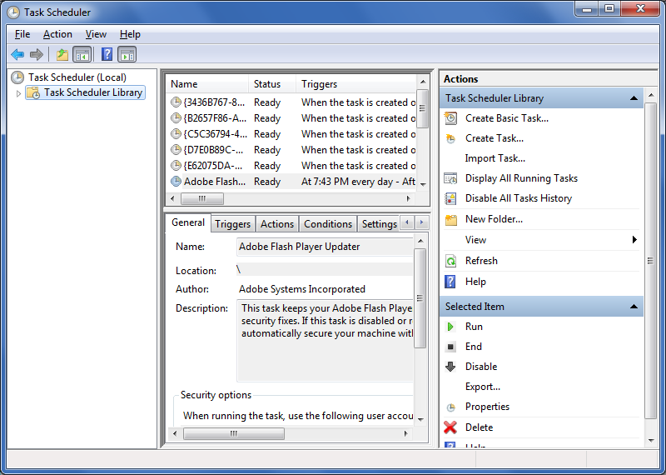
- Click Create Basic Task
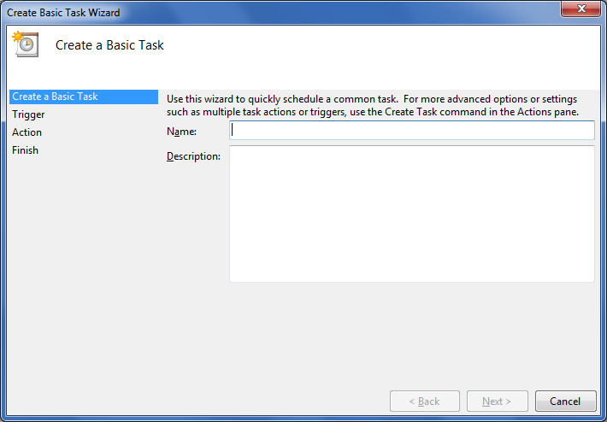
- Name must be: sjsbackup
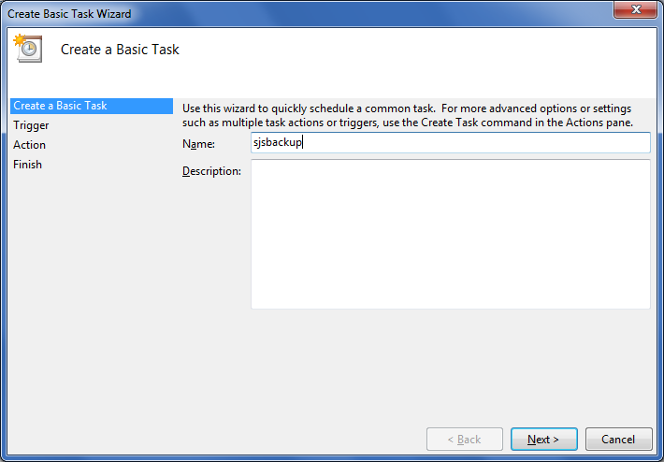
- Click Next; select “Daily”; click Next
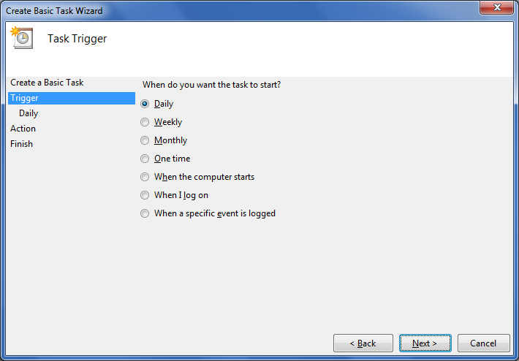
- Schedule the start time; click “Next”:
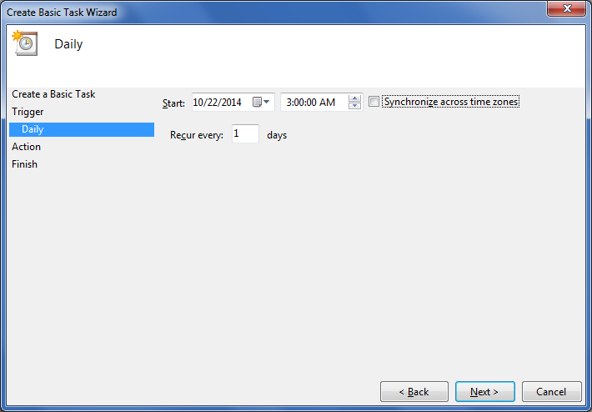
Select “Start a program”; click “Next”:
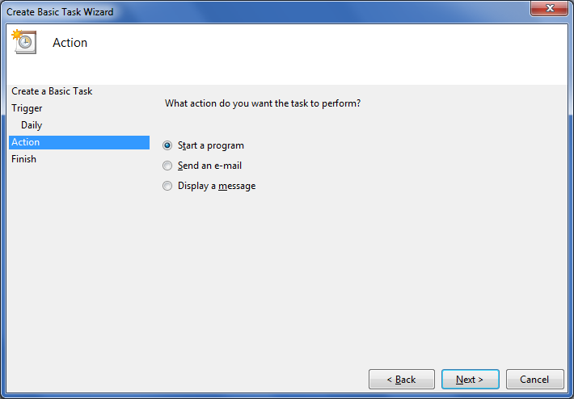

- Browse to and select the batch file C:\SJS_ColdBackup11xe\sjs_coldbackup11xe.bat
- Add a backslash \ in the Start input box; click “Next”: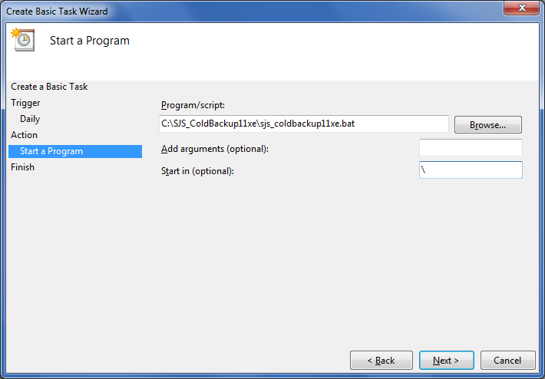

- Check “Open the Properties dialog box for this task when I click Finish”; click “Finish”:

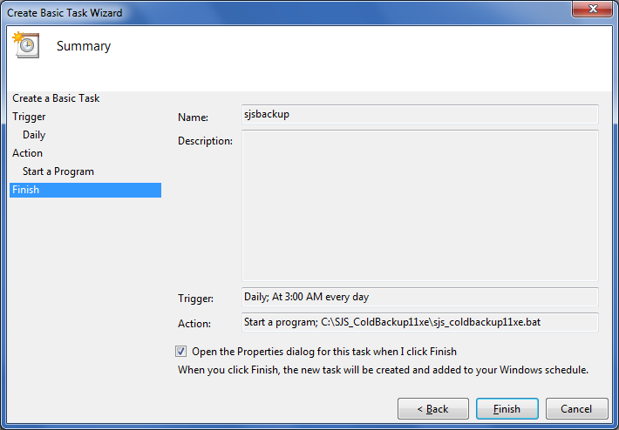
- Check “Run with highest privileges”.
- Select “Configure for” “Windows 7, Winders Server 2008 R2.
- Click “Ok”:
- Run the task, select from the list, right click and select “Run”:
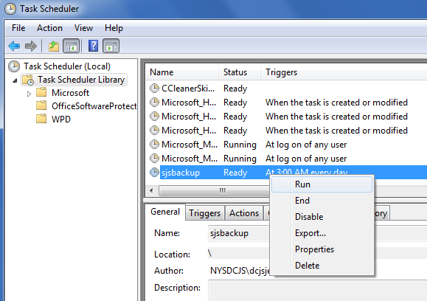

Recover from Backup
- Stop the following services
  - Apache Tomcat
  - OracleServiceXE
- Review of database files
- Backup existing database files
- Deploy backup

Stop the following services before backup recovery:
- Apache Tomcat
- OracleServicesXE

Review of database files
11 G Express database directories:
- \oraclexe\app\oracle\fast_recovery_area\XE\ONLINELOG
  - 2 LOG files
- \oraclexe\app\oracle\oradata\XE
  - 6 DBF files
- \oraclexe\app\oracle\product\11.2.0\server\database
  - 5 Files: 2 ORA, 1 DAT, 1 LOG, 1 EXE

11 G Express database files directory path:
- \oraclexe\app\oracle\fast_recovery_area\XE\ONLINELOG\O1_MF_1_B3BJB33C_.LOG *
- \oraclexe\app\oracle\fast_recovery_area\XE\ONLINELOG\O1_MF_2_B3BJB4NO_.LOG *
- \oraclexe\app\oracle\oradata\XE\CONTROL.DBF
- \oraclexe\app\oracle\oradata\XE\SYSAUX.DBF
- \oraclexe\app\oracle\oradata\XE\SYSTEM.DBF
- \oraclexe\app\oracle\oradata\XE\TEMP.DBF
- \oraclexe\app\oracle\oradata\XE\UNDOTBS1.DBF
- \oraclexe\app\oracle\oradata\XE\USERS.DBF
- \oraclexe\app\oracle\product\11.2.0\server\database\hc_xe.dat
- \oraclexe\app\oracle\product\11.2.0\server\database\initXE.ora
- \oraclexe\app\oracle\product\11.2.0\server\database\oradba.exe
- \oraclexe\app\oracle\product\11.2.0\server\database\oradim.log
- \oraclexe\app\oracle\product\11.2.0\server\database\pwdxe.ora

Backup utilities database file directory path in either designated “backups” or “archives” locations
- \YYYYMMDDHHMMSS\oraclexe\app\oracle\fast_recovery_area\XE\ONLINELOG\O1_MF_1_B3BJB33C_.LOG *
- \YYYYMMDDHHMMSS\oraclexe\app\oracle\fast_recovery_area\XE\ONLINELOG\O1_MF_2_B3BJB4NO_.LOG *
- \YYYYMMDDHHMMSS\oraclexe\app\oracle\oradata\XE\CONTROL.DBF
- \YYYYMMDDHHMMSS\oraclexe\app\oracle\oradata\XE\SYSAUX.DBF
- \YYYYMMDDHHMMSS\oraclexe\app\oracle\oradata\XE\SYSTEM.DBF
- \YYYYMMDDHHMMSS\oraclexe\app\oracle\oradata\XE\TEMP.DBF
- \YYYYMMDDHHMMSS\oraclexe\app\oracle\oradata\XE\UNDOTBS1.DBF
- \YYYYMMDDHHMMSS\oraclexe\app\oracle\oradata\XE\USERS.DBF
- \YYYYMMDDHHMMSS\oraclexe\app\oracle\product\11.2.0\server\database\hc_xe.dat
- \YYYYMMDDHHMMSS\oraclexe\app\oracle\product\11.2.0\server\database\initXE.ora
- \YYYYMMDDHHMMSS\oraclexe\app\oracle\product\11.2.0\server\database\oradba.exe
- \YYYYMMDDHHMMSS\oraclexe\app\oracle\product\11.2.0\server\database\oradim.log
- \YYYYMMDDHHMMSS\oraclexe\app\oracle\product\11.2.0\server\database\pwdxe.ora

* File name will verify by installation.

Backup existing database files

To recover from backup- do not delete the existing database files; create a subdirectory and move them for temporary storage. OracleServiceXE MUST BE STOPPED.

- \oraclexe\app\oracle\fast_recovery_area\XE\ONLINELOG\backup
- \oraclexe\app\oracle\oradata\XE\backup
- \oraclexe\app\oracle\product\11.2.0\server\database\backup

Move:
- \oraclexe\app\oracle\fast_recovery_area\XE\ONLINELOG\backup \O1_MF_1_B3BJB33C_.LOG
- \oraclexe\app\oracle\fast_recovery_area\XE\ONLINELOG\backup \O1_MF_2_B3BJB4NO_.LOG
To:
- \oraclexe\app\oracle\fast_recovery_area\XE\ONLINELOG\O1_MF_1_B3BJB33C_.LOG
- \oraclexe\app\oracle\fast_recovery_area\XE\ONLINELOG\O1_MF_2_B3BJB4NO_.LOG

Move:
- \oraclexe\app\oracle\oradata\XE\CONTROL.DBF
- \oraclexe\app\oracle\oradata\XE\SYSAUX.DBF
- \oraclexe\app\oracle\oradata\XE\SYSTEM.DBF
- \oraclexe\app\oracle\oradata\XE\TEMP.DBF
- \oraclexe\app\oracle\oradata\XE\UNDOTBS1.DBF
- \oraclexe\app\oracle\oradata\XE\USERS.DBF
To:
- \oraclexe\app\oracle\oradata\XE\backup \CONTROL.DBF
- \oraclexe\app\oracle\oradata\XE\backup \SYSAUX.DBF
- \oraclexe\app\oracle\oradata\XE\backup \SYSTEM.DBF
- \oraclexe\app\oracle\oradata\XE\backup \TEMP.DBF
- \oraclexe\app\oracle\oradata\XE\backup \UNDOTBS1.DBF
- \oraclexe\app\oracle\oradata\XE\backup \USERS.DBF

Move:
- \oraclexe\app\oracle\product\11.2.0\server\database\hc_xe.dat
- \oraclexe\app\oracle\product\11.2.0\server\database\initXE.ora
- \oraclexe\app\oracle\product\11.2.0\server\database\oradba.exe
- \oraclexe\app\oracle\product\11.2.0\server\database\oradim.log
- \oraclexe\app\oracle\product\11.2.0\server\database\pwdxe.ora
To:
- \oraclexe\app\oracle\product\11.2.0\server\database\backup\hc_xe.dat
- \oraclexe\app\oracle\product\11.2.0\server\database\backup\initXE.ora
- \oraclexe\app\oracle\product\11.2.0\server\database\backup\oradba.exe
- \oraclexe\app\oracle\product\11.2.0\server\database\backup\oradim.log
- \oraclexe\app\oracle\product\11.2.0\server\database\backup\pwdxe.ora

To recover from backup
Move:
- \YYYYMMDDHHMMSS\oraclexe\app\oracle\fast_recovery_area\XE\ONLINELOG\O1_MF_1_B3BJB33C_.LOG *
- \YYYYMMDDHHMMSS\oraclexe\app\oracle\fast_recovery_area\XE\ONLINELOG\O1_MF_2_B3BJB4NO_.LOG *
To:
- \oraclexe\app\oracle\fast_recovery_area\XE\ONLINELOG\backup \O1_MF_1_B3BJB33C_.LOG
- \oraclexe\app\oracle\fast_recovery_area\XE\ONLINELOG\backup \O1_MF_2_B3BJB4NO_.LOG

Move:
- \YYYYMMDDHHMMSS\oraclexe\app\oracle\oradata\XE\CONTROL.DBF
- \YYYYMMDDHHMMSS\oraclexe\app\oracle\oradata\XE\SYSAUX.DBF
- \YYYYMMDDHHMMSS\oraclexe\app\oracle\oradata\XE\SYSTEM.DBF
- \YYYYMMDDHHMMSS\oraclexe\app\oracle\oradata\XE\TEMP.DBF
- \YYYYMMDDHHMMSS\oraclexe\app\oracle\oradata\XE\UNDOTBS1.DBF
- \YYYYMMDDHHMMSS\oraclexe\app\oracle\oradata\XE\USERS.DBF
To:
- \oraclexe\app\oracle\oradata\XE\CONTROL.DBF
- \oraclexe\app\oracle\oradata\XE\SYSAUX.DBF
- \oraclexe\app\oracle\oradata\XE\SYSTEM.DBF
- \oraclexe\app\oracle\oradata\XE\TEMP.DBF
- \oraclexe\app\oracle\oradata\XE\UNDOTBS1.DBF
- \oraclexe\app\oracle\oradata\XE\USERS.DBF

Move:
- \YYYYMMDDHHMMSS\oraclexe\app\oracle\product\11.2.0\server\database\hc_xe.dat
- \YYYYMMDDHHMMSS\oraclexe\app\oracle\product\11.2.0\server\database\initXE.ora
- \YYYYMMDDHHMMSS\oraclexe\app\oracle\product\11.2.0\server\database\oradba.exe
- \YYYYMMDDHHMMSS\oraclexe\app\oracle\product\11.2.0\server\database\oradim.log
- \YYYYMMDDHHMMSS\oraclexe\app\oracle\product\11.2.0\server\database\pwdxe.ora
To:
- \oraclexe\app\oracle\product\11.2.0\server\database\hc_xe.dat
- \oraclexe\app\oracle\product\11.2.0\server\database\initXE.ora
- \oraclexe\app\oracle\product\11.2.0\server\database\oradba.exe
- \oraclexe\app\oracle\product\11.2.0\server\database\oradim.log
- \oraclexe\app\oracle\product\11.2.0\server\database\pwdxe.ora

Restart Services in the following order:
- OracleServiceXE
- Apache Tomcat

3rd option for keeping the backup utility similar to the old but to allow for backup retention

Here's a third option, keep just a backup folder/ retention day only.

To start:
- Comment line 8 by adding a "rem" at the start:
  - Line 8: rem set retain_archive=14
- Comment line 18 by adding a "rem" at the start:
  - Line 18: rem set archive_location=%util_folder%archives

For Option 1 Local or mapped drives do the following:
- Comment line 66 by adding a "rem" at the start:
  - Line 66: rem %util_tool%forfiles /p %backup_location% /d -%retain_backup% /c "cmd /c move @file %archive_location%"
- Change line 67 from:
  - Line 67: %util_tool%forfiles /p %archive_location% /m * /d -%retain_archive% /c "cmd /c rmdir /s/q @file"
- Change line 67 to:
  - Line 67: %util_tool%forfiles /p %backup_location% /m * /d -%retain_backup% /c "cmd /c rmdir /s/q @file"

For Option 2 UNC Paths
- Be sure you've commented the Location Option 1 path assignments between lines 17-21.
  - Comment out line 27 by adding a rem to the start:
    - Line 27: rem set archive_location=\\pvwap22\sjsdata\test\archives
- Comment lines 65-68 by adding a "rem" at the start:
  - Line 65: rem (
  - Line 66: rem %util_tool%forfiles /p %backup_location% /d -%retain_backup% /c "cmd /c move @file %archive_location%"
  - Line 67: rem %util_tool%forfiles /p %archive_location% /m * /d -%retain_archive% /c "cmd /c rmdir /s/q @file"
  - Line 68: rem ) >> sjs_coldbackup11xe.log 2>&1
- Uncomment lines 73-76, and line 80. Edit line 75 as depicted in the before and after shots below:
  - Change from:
- Line 73: rem (
- Line 74: rem pushd %backup_location%
- Line 75: rem %util_tool%forfiles /d -%retain_backup% /c "cmd /c move @file %archive_location%"
- Line 76: rem popd
- Line 77: rem pushd %archive_location%
- Line 78: rem %util_tool%forfiles /m * /d -%retain_archive% /c "cmd /c rmdir /s/q @file"
- Line 79: rem popd
- Line 80: rem ) >> sjs_coldbackup11xe.log 2>&
- Change to:
  - Line 73: (
  - Line 74: pushd %backup_location%
  - Line 75: %util_tool%forfiles /m /d -%retain_backup% /c "cmd /c rmdir /s/q @file%"
  - Line 76: Popd
  - Line 77: rem pushd %archive_location%
  - Line 78: rem %util_tool%forfiles /m * /d -%retain_archive% /c "cmd /c rmdir /s/q @file"
  - Line 79: rem popd
  - Line 80: ) >> sjs_coldbackup11xe.log 2>&

