User’s Guide

OPDF Grants Management System

Version 1.0.0

April 15, 2004

Table of Contents

User’s Guide
Introduction 1

Logging-In and Logging-Out 3

GMS Navigation 6

Project Module 12

Attachment Module 22

Progress Report Module 24

Site Review Report Module 28

Financial Report Module 31

Property Report Module 36

Reports 40

Glossary i

Introduction

This document is the user’s guide for the Grants Management System (GMS) developed for the Division of Criminal Justice Services Office of Program Development and Funding (OPDF) by Network Systems Integration, Inc.

GMS is a web-based system for OPDF staff interaction with applicants and grantees. A key feature is the ability of the system to implement a role-based security system that will control access rights throughout the GMS system.

This document is to be used as a reference guide to enable GMS users to enter, view, retrieve, and query grant data from the electronic database. The following general statements are pertinent:

- All data used in the examples and screens throughout this guide are not actual grant data. This has been done to comply with the confidentiality assigned to all the information contained in grant documents.

- The organization of the user’s guide follows the order of modules, as they appear listed on the left frame of the GMS “Welcome” screen.

- The user’s guide has been written assuming that a user has 'Grantee' rights in accessing the GMS.

- It is assumed that all GMS users will access GMS through their browser (Netscape or Internet Explorer.)

- Prospective applicants, awardees and grantees can log in to submit grant information for processing by OPDF. GMS limits access to modules, tabs and fields. Applicants, awardees and grantees have access to their information, but not to any project information about other applicants, awardees or grantees.

- OPDF staff has access to projects and the appropriate modules with regard to their job responsibilities.

- Buttons, lists, check boxes, and other dialog box elements are displayed in italics.

- In the instructions, this checkmark indicates a step the user needs to take to accomplish the outlined task.

GMS system consists of the following modules:

GMS Modules
Module | Function
Project | Captures the information provided by an applicant when requesting funds as part of a grant application.
Attachment | Contains any documentation that the grantee wishes to include with their application. (not secure from intrusion; do not attach sensitive information)
Progress (Reporting module) | Contains progress reports submitted by the grantee during the length of the project.
Site Review (Reporting module) | Contains the documentation of official site visits made by OPDF personnel.
Financial (Reporting module) | Contains all the financial reports submitted by the grantee throughout the life cycle of the grant.
Property (Reporting module) | Contains reports of any purchased property or equipment with grant funds.

Logging-In and Logging-Out

Browser
GMS is designed as a web page and requires a browser to access the program. Either Internet Explorer version 5.5 (or greater) or Netscape version 4.0 (or greater) is recommended. To check your browser version:
- Open your browser.
- Click on Help.
- Click the About option. The version number will be found there.

To access GMS, register with OPDF by using the registration form provided at http://criminaljustice.state.ny.us/ofpa/gms.htm .

The initial Welcome page, will be displayed:

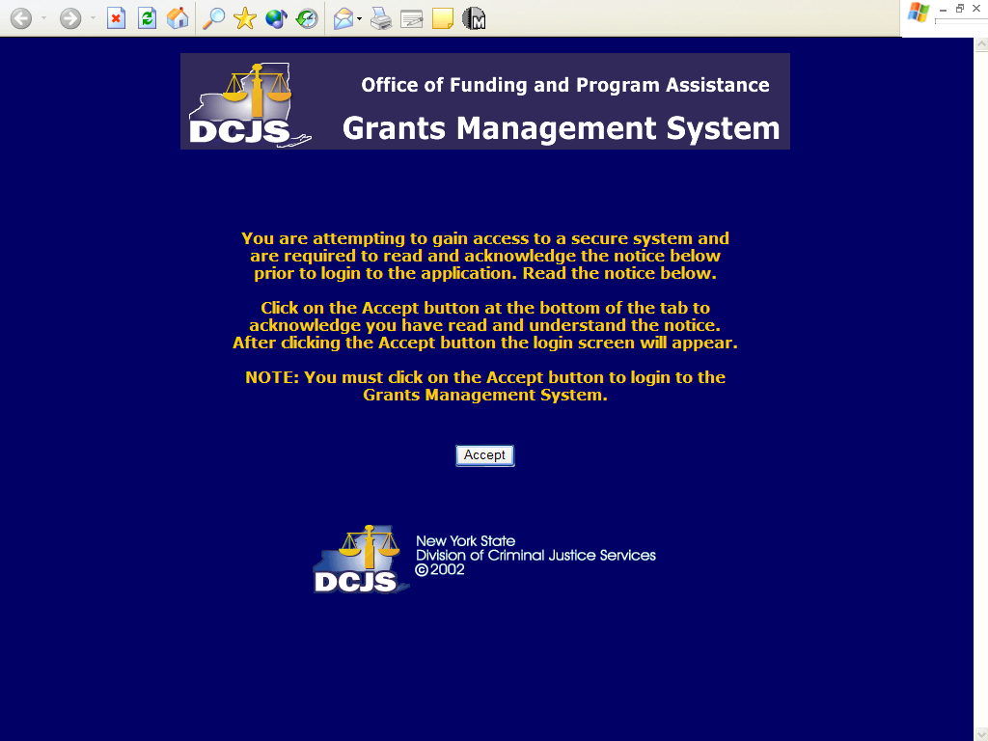
Figure 1: Initial acceptance screen of DCJS GMS

This screen prompts the user to acknowledge that a secured system is being accessed.
- Click on the “Accept” button to access the GMS login page.

Logging-In

To Log-in:
- Enter your Login Name.
- Enter your password.
- Click on the Submit button to gain access to the GMS.

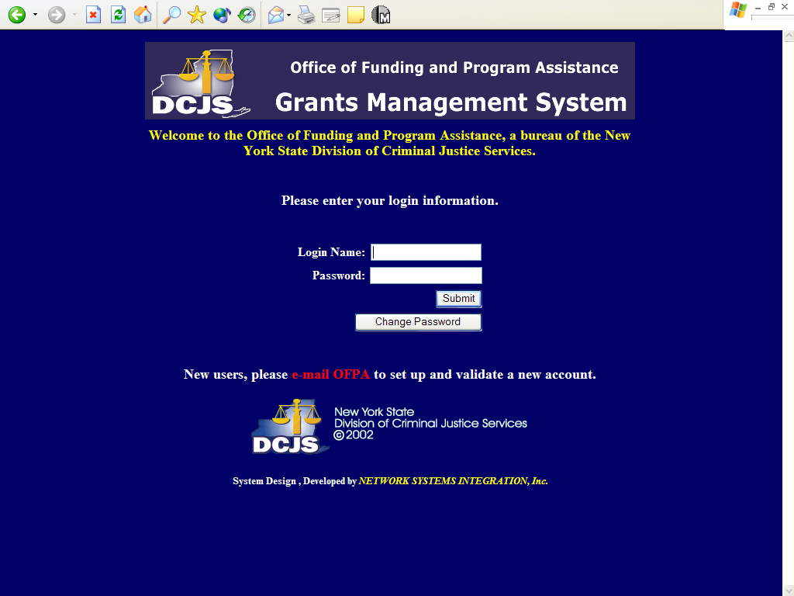
Figure 2: Login screen

- A Welcome screen appears. Click on the title in the left frame for the module you want.

Changing Passwords

The login page also allows authorized users to change their password:
- Enter your Login Name.
- Enter your Password.
- Click on the Change Password button.
- On the next screen enter your Login Name and Password.
- Enter your new password, in the New Password box (Passwords must be at least 8 characters, and contain at least one symbol, such as *).
- Re-enter the new password, in the Confirm New Password box.
- Click Save Change.
The next time you log-in you must use the new password.

Logging-Out

When you want to exit GMS (logout),

- Within any of the GMS pages, click the Logout button located towards the bottom of the left frame.

GMS Navigation

This section describes the various components of the GMS pages and provides tips and suggestions for navigating GMS.

GMS Page Components

To provide consistency throughout the GMS, the various pages were created with the same organization. That is, each GMS page consists of the browser toolbar, a left frame, a right frame, a header, a content area, and a footer.

Navigation through the GMS pages is possible by clicking on the various types of “links” that have been created on each screen or page. These links can be tabs, hyperlinks, buttons, or pick-lists and when you click on them the system takes you to another page within the GMS. The following figure is an example of one of the GMS pages:

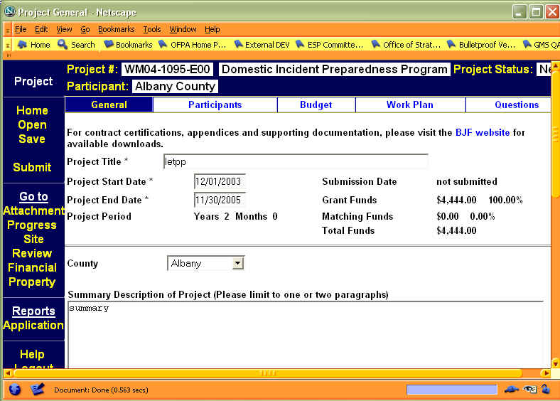
Figure 3: A Sample GMS Page

Browser Toolbar
The top of the GMS screen normally will be filled with the browser toolbar (Internet Explorer or Netscape). The rest of the screen will contain the GMS page.

GMS Frames
GMS pages were designed with two frames (or parts). These two frames are always displayed below the browser toolbar. Based on user rights, some of the following choices will not be seen or will be “greyed” out and not accessible to the user. Some comments in this regard are included below.

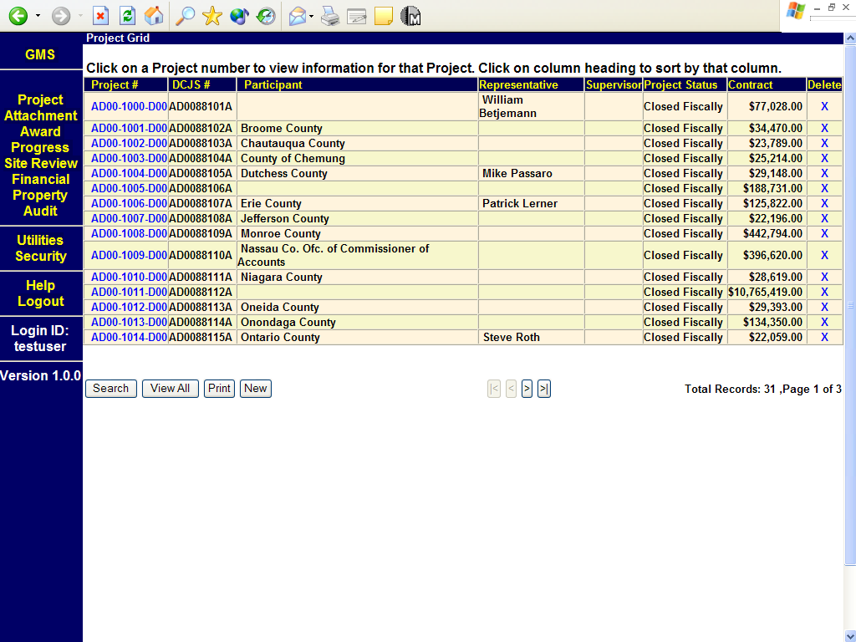
Figure 4: List of the Projects, (Project Grid)

Left Frame
Words in yellow are links to other screens; words in white are headings. In the following discussion all the choices available are listed, some users may not be able to access every choice, because of restrictions.

Before selecting a project the left frame has the following choices:

Left Frame Choices
Choice | Function
GMS | Takes the user to the GMS Welcome screen
Project  Attachment  Award  Progress  Site Review  Financial  Property  Audit | Takes the user to the appropriate module’s initial page.
Utilities  Security | Restricted access modules for administrating GMS functions
Help  Logout | Takes the user to Help screen or Logout, respectively
Login ID | Indicates the sign in ID of the current user.
Version | Lists the open version of GMS

After selecting a project the left frame has the following choices:

Left Frame Choices
Choice | Function
Name of the current module | In our illustration it is Project.
Home | Takes the user to the GMS Welcome screen
Open | Takes the user back to the grid, showing all of the projects.
Save | Saves any changes which the user may have made. (If available according to user and record status)
Submit | (Seen only by a grantee, when the project status is New and at least one participant is entered.) Clicking this button changes the status of the grant to Application Received.
Attachment  Award  Progress  Site Review  Financial  Property  Audit | Lists the other modules for the selected project. Clicking on one of these choices takes the user to the actual attachments, awards, progress, etc. of the selected project and not to the initial screen.
Reports | Under this heading will be a list of the reports that can be printed. The reports listed will vary according to the status of the project.
Application | A printable five page summary of the application.
Deficiency | A report of the areas where OPDF has determined that the application information submitted is not yet adequate to generate a contract.
Contract | A report showing the current status of the application.
Award | The contract after the project is approved for funding.
Help  Logout | Takes the user to Help screen or Logout, respectively
Login ID | Indicates the sign in ID of the current user.
Version | Lists the open version of GMS

Right Frame
The right frame displays the various GMS pages normally consisting of a listing of records or contents of records for the module selected from the left frame.

Header
The top of the GMS page is the header area. Before a project is selected this area displays brief instructions about accessing individual records. After a project is selected this area displays information – Project #, Funding Source, Participant, Project Status – about the project that is displayed in the body of the page. On some GMS pages the header area also displays tabs that are used to separate the GMS data for ease of viewing.

Footer
The GMS footer area shows various buttons to perform actions on the grid above as well as counters displaying the project record counts. The following table includes the most common buttons. Some individual modules have other buttons which will be described in context.

Common Buttons Found in the Screen’s Footer
Button | Function
Search | Allows the user to conduct a search by entering one or more parameters in the search screen.
View All | After a search will display all of the projects that the user has a right to see.
Print | Allows the user to print a form using the record currently selected.
New | Allows the user to enter a new record for the selected module.
|< | Goes to the FIRST page of records.
< | Goes to the PREVIOUS page of records.
> | Goes to the NEXT page of records.
>| | Goes to the LAST page of records.

Since large numbers of Project records cannot be displayed on the screen at the same time, in the bottom right corner, there is a counter displaying the total number of Project records. In addition, the page number currently being displayed is shown, as well as the total number of pages available.

Remember that only the records that match the access rights of the user will be displayed.

Content Area
The majority section of the GMS page displays the content or record information. If tabs are present in the GMS header, then the data displayed corresponds to the tab currently selected. In other instances the GMS content page may display a grid containing a series of records for the GMS module selected.

Grids
A grid appears when a module is selected from the left frame of the Welcome page. The grid is a table with a series of rows, known as records, that correspond to different projects stored within GMS. Based on user rights, the records shown correspond to the supporting organization for which the user has been registered. In examples in this manual the user has the right to see all the projects in the GMS.

The grids for the different modules look very similar. The grid is a display of the projects within the database Depending on which grid one is in when one clicks a project, one will get different results. The grid name is just above the left side of the table. For example, selecting a project when in the Attachment grid will display the attachments for the project; selecting a project when in the Financial grid will display the financial reports for the selected project, etc.

Within a grid, any words or numbers in blue are a link to that item. E.g., the user may click on the blue project name and go to the information on that project.

Tabs
When looking at a specific project in the project module a series of tabs will be seen across the top of the Content Area. GMS divides the modules into various pages to organize the information. To access the contents within a particular tab simply click on that tab. Specific tabs are explained within the appropriate context.

Pick-lists
Several fields in the system require the user to place a value in the field by selecting it from a predefined list of options. This is called a pick-list. For example, to enter the name of a staff member, click on the arrow on the right side of the box, scroll through the names, and select the name by clicking on it. If the list of values is long, hit a letter or number to quickly skip through records.

Navigational Tips

The following suggestions are presented to allow the user to most effectively use the GMS.

Resizing Screen Text
In both browsers it is possible to change the size of the text shown on some of the GMS pages. In Internet Explorer select the size of the text within the Text Size item from the View menu. In Netscape, select the Character Set item from the View menu.

Exiting GMS
The proper way to exit the GMS is to click the Logout link located towards the bottom of the left frame. Exiting by clicking on the X button on the top right corner may introduce undesired behavior of the GMS.

Going Back to a previous GMS Page
It is not recommended to use the Internet Explorer or Netscape Back button to go to previous pages of the GMS web application. Doing so may cause undesired behavior of the GMS. Instead, use the navigation buttons and links that are provided within the application.

Time-out
The GMS has a time-out feature that will log a user out if no activity is detected. To prevent being logged-out of the GMS, we recommend that you log out from the GMS if you are going to leave your desk or are not planning to use the GMS for more than thirty minutes.
Project Module

The Project module of the GMS captures the information that is provided by an applicant when requesting funds as part of a grant application.

Prospective and continuing grantees can view, enter and print grant application information and instructions from the Internet for all grant programs with OPDF. Further, the grantee can enter project information on-line and submit the grant application when it is completed.

After the applicant submits the grant, OPDF staff has access to the grant information and can process it.

Accessing the Project Grid

To access the GMS Project module, follow these steps:
- Log in to the GMS.
- Click on the Project link on the left frame of the GMS Welcome page. The Project grid will display in the right frame of the screen. (The sections of the screen are fully described in the GMS Navigation section, on page 6.

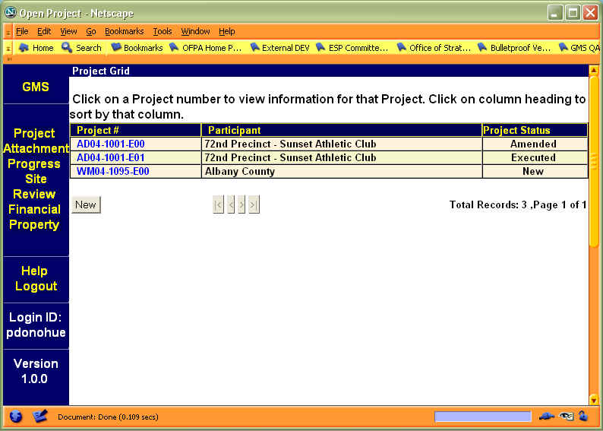
Figure 4: Project Grid

Remember that only the records that match the access rights of the user will be displayed. In the above example, the user accessing this page has the rights to see all the projects in the GMS.

After selecting a project, this module has the heading Reports added to the left frame. There will be different reports listed depending on the status of the application. (These are explained in the GMS Navigation section on page 8.) Clicking on any of the options will display the respective report.

Project Grid Columns
The data in the Project grid is presented in three columns of information. These columns are:

Project Module Columns
Column Title | Definition
Project # | A unique number for the project. The components are described below.
Participant | Name of a group that is involved in the execution of the project.
Project Status | Refers to the current standing of the project. E.g., Application Received, Under Review, Contract Executed

Project #
The Project # indicates the Funding Program Type with the first two letters, the calendar year with the next two digits, a sequential number with the next four digits, the next digit (letter) indicates whether the application was submitted on line (E) or on paper (D) and the last two digits indicate the number of copies (See: Copying a Project) of this proposal, the highest number being the latest.

For example: CC04-1032-D00 project was funded by Capital Crimes with the initial year being 2004, it has a sequence number of 1032, it was submitted on paper and this is the first copy of the project.
And: AD05-1001-E02 project was funded by Aid to Defense with the initial year being 2005, it has a sequence number of 1001, it was submitted on line, and there are two copies of the project, i.e., it has had two amendment requests.

Accessing Specific Projects

GMS has organized the Project data into five sections or “tabs”; which are: General, Participants, Budget, Work Plan, Questions

The Project Module’s sections (tabs) are:

Project Module Tabs
Tab | Information
General | Has the title, dates of the project, project number, DCJS number, etc. about the project.
Participant | Lists the organizations which will be taking part in the project. Contact information for individuals within the organizations is located under this tab.
Work Plan | Contains the goals and their objectives and the objectives tasks for this project.
Budget | Has the financial plan information for the project.
Questions | Contains questions generated when certain funding sources have been selected.

To access a specific project, follow these steps:
- Log in to the GMS.
- Click on Project in the GMS Welcome page.
- Click on the Project # (displayed in blue).
  - The General Tab data for the selected project will then display in the right frame of the screen.
- To view or enter data in another tab, click on that tab.

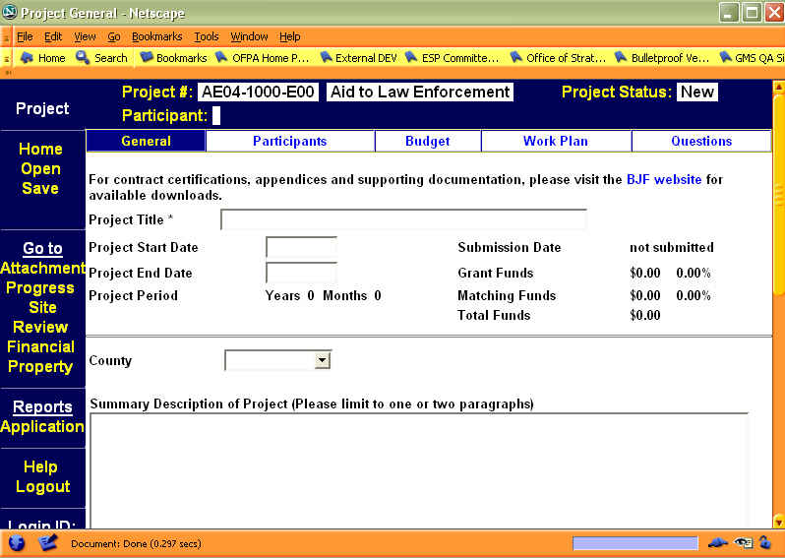
Figure 5: General Tab of the Project Module

Creating a New Project

Creating a project makes a new application for funding and is usually initiated by the applicant.

The Project Status will remain as “New” throughout the data entry process. The status will change on submission and the project will be locked to further data entry until approved by OPDF or reopened for editing by OPDF staff.

To create a new project follow these steps:
- Log in to the GMS.
- Click on Project in the GMS Welcome page.
- Click on the New button at the bottom of the Project Grid. The right frame will refresh to show the Create Project button and a pick-list box for selecting the Funding Program.

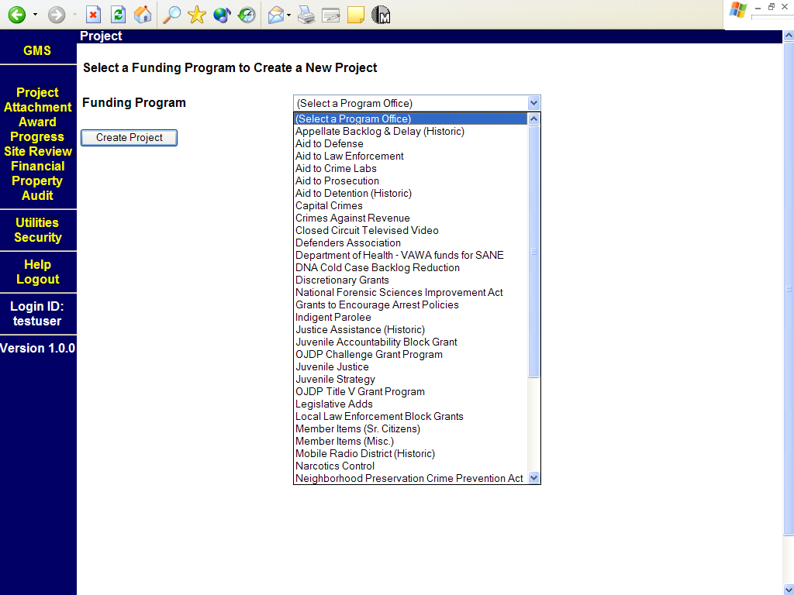
Figure 6: Selecting a funding program while creating a new project/application.

Before reaching the tabs one must select the appropriate funding source:
Select Funding Program
- Click on the down arrow in the pick list box for funding programs.
- Scroll down with the mouse until the desired funding program is highlighted.
- Click the left mouse button.
- Click the Create Project button to start the creation of the new project.
- Click the OK button on the dialog box to confirm the creation of the project.

The first screen will be the General Tab.

General Tab
The right frame of the screen will show the Project Header, the Project Tabs, and the data for the first Project Tab, i.e. the General Page. Notice that the Project # has been automatically generated and that the Project Status shows the project as being New.
- Enter the Project data into the various data fields for the General tab. Most fields are self explanatory.
    - Required fields are: Project Title. Mandatory data must be entered before the record can be saved.
- When done, click on the Save button at the bottom of the page or the Save option on the left frame.

Figure 7: General Tab for the Project Module

Participants Tab
- Enter the participant information by clicking the Participants tab. Click the Add Participant button to search for an existing participant.
  - Either enter the name you wish to search for, click OK and a list of matching names will appear, if any. Click on the name of the partcipant you wish to add, select the type and it will be added to the project.
    - NOTE: The first participant will be added as a Grantee, the second as 'other'. You may click on the participants you have added and choose other participant types (Grantee, Implementing Agency, Other) from the drop-down list.
  - Or just click OK and a complete list of participants will be displayed. Scroll down and click on the appropriate participant, click OK, if you wish to add that participant to the project, if not click Cancel.
- However, if the participant is not in the data base you may add them by clicking on the New button on the screen that lists the participants.
    - Required fields are: Participant Name, Address, City, State and Zip. Mandatory data must be entered before the record can be saved.
- When done, click on Save.
- To enter the contact information for participants, use the drop down box under “Contacts for Participant” to select the new participant, then click the Add Contact button.
    - Required fields are: First Name, Last Name and Phone. Mandatory data must be entered before the record can be saved.
    - Add a minimum of one Primary, Fiscal and Signatory contact for the Project.
- When done, click on Save.
Note: GMS allows for multiple participants in a given project (such as the members of a collaboration or consortium). Please enter or choose contact data for only the Primary Participating Agency (Implementing Agency). Full contact information is not required for each collaborative member.

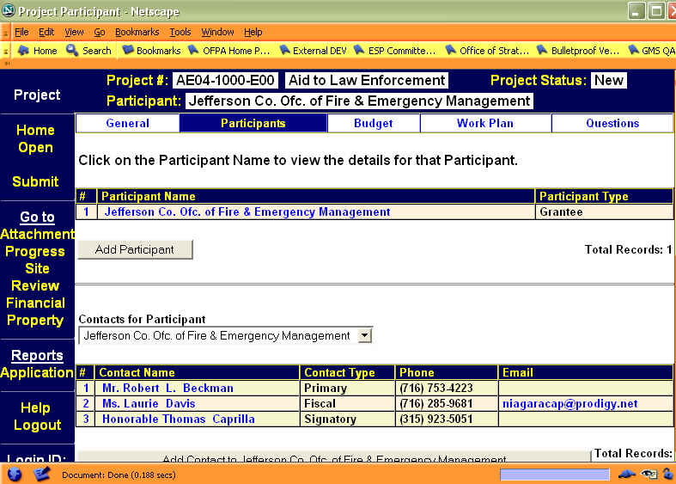
Figure 8: Participant Tab for the Project Module

Budget Tab
- Click on the Budget tab, to enter budget information. You must have at least one participant before you can enter budget data. You may add separate budgets for each participant.
  - The first time you enter a record the budget will be automatically assigned the number “1.”
- Click on the Create new Budget Version for participant's name to add the budget data for that participant.
    - The next screen displays the fields for the budget information required. There are nine budget categories: Personnel, Fringe Benefits, Consultant Services, Equipment, Supplies, Travel and Subsistence, Rental of Facilities, Alterations and Renovations, and All Other Expenses.
- For that participant fill in the relevant categories.
    - For each category, the required fields are: Description, Number, Unit Cost, and Justification. Mandatory data must be entered before the record can be saved.
- When done, click on Save. Repeat these steps as necessary to complete all needed budget categories.
- Click Back to Budget Summary to see the completed budget, or to create a new budget for another participant.
- Repeat these steps for each participant.

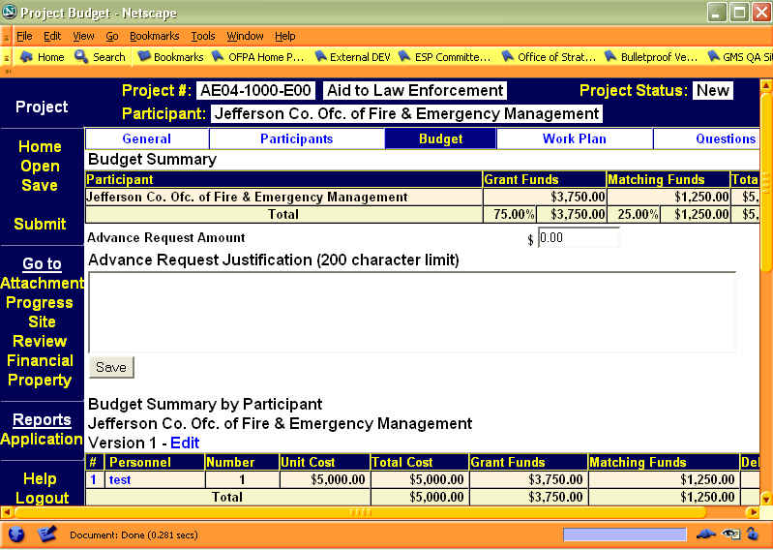
Figure 9: Budget Tab for Project Module

Work Plan Tab
- Click on the Work Plan tab.
- Enter the Project Goal in the appropriate box.
- When done, click on Save.
- To add an objective, click on the Create New Objective button and add the objective in the text box. Several objectives can be created.
- When done, click on Save.
- To add a task, click on the Add Task to this Objective button. Describe the task in the first text box. Provide specific performance measurements in the next text box.
    - Notice that both of these text boxes are mandatory fields. Mandatory data must be entered before the record can be saved. Several tasks can be created for each objective.
- When done, click on Save.

Each objective is listed separately with the relevant tasks below them.

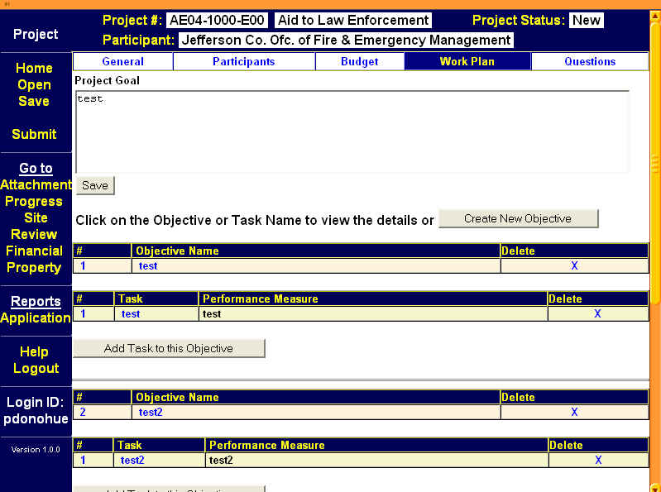
Figure 10: Workplan Tab of the Project Module

Questions Tab
When a funding program is selected (in the initial step for creating a project) several questions may be generated if required by that program. These questions will be displayed under this tab for the applicant to answer.

- Click on the Questions tab.
- Click on the question link and enter the answer in the answer text box.
- When done, click on Save.

Submitting a Grant

The applicant can fill out the information on the project at leisure. GMS will save the data and allow the applicant to return to the application, until the application is submitted. To submit a grant follow the steps below:
- Log in to the GMS.
- Click on the Project option from the GMS main menu.
- Select the project.
- Check that the application is filled out completely.
- In the Attachments module, add any attachments that are relevant to the project.
- In the left frame under Save click on the word Submit. OPDF will be notified of a new application and all the fields will be locked to the grantee. If any required fields have been left blank, GMS will generate a printable Required Fields Report to guide you in finishing the application.

What to Expect After Submission

Following notification that a grant application has been submitted, OPDF staff will review the application for completeness and, in the case of competitive grants, eligibility for funding. OPDF will notify the grantee to edit and resubmit the application, if necessary, and areas requiring additional or altered information (noted by a red-colored 'Deficiency' flag on the page or module) will be reopened to the grantee for editing. The grantee may view the status of their application or grant contract by simply logging into GMS and noting the status indicated on the Project Grid for the project of interest.

Attachment Module

The Attachment module contains any documentation that the grantee wishes to include with their submission.

Prospective and continuing grantees can include electronic submissions of any project documentation associated with their project.

The OPDF staff can view any documentation submitted by grantees that would be associated with a project.

Accessing the Attachment Grid

To access the GMS Attachment module:
- Log in to the GMS.
- Click on the Attachment link on the left frame of the GMS Welcome page. The Attachment grid will then display on the right frame of the screen. (The sections of the screen are fully described in the GMS Navigation section, on page 6.)

To Add Attachments

- From the list of Attachments screen, click on the New button. The current date will be entered by GMS as the Entered Date.
- A text box is to the right of "Select the file to be uploaded".
  - Either click on the Browse button to the right of that box and select the appropriate file,
  - Or type in the path and name of the file you wish to attach.
- Click on Upload.
The file will be uploaded and a message will appear to that effect. You may upload more files or click on Go Back to List to return to the list of attachments associated with that project.

Accessing Specific Attachments

To access an Attachment data for a specific Project,
- Log in to the GMS.
- Click on the Attachment link.
- Click on the Project # (displayed in blue). A list of the Attachments for that project will then display in the right frame of the screen. If no Attachments are displayed then, that project does not have any attachments.

The data in the Attachment List grid are presented in tabular format showing three columns of information. These columns are: #, Entered, and Attachment Name.

- Click on the Attachment Name (displayed in blue). The attachment will load into a separate browser frame.
- To return to the list of attachments, click on the X in the upper right hand corner of the Attachment’s text.

Progress Report Module

The Progress module of the GMS contains progress reports submitted by the grantee during the length of the project. Grantees can create, read, update and submit information pertaining to non-submitted progress reports. However, after a progress report has been submitted, then the grantee has only read rights to that progress report. The grantee can create, read, update and submit other progress reports.

The goal, objective and task information displayed in the Progress Report Module was entered in the Project Module, Workplan Outcomes Tab. During the life of the grant no other goals, objectives or tasks can be added to the project except when an amendment has been requested by letter to OPDF and approved.

Accessing the Progress Reports Grid

To access the GMS Progress module:
- Log in to the GMS.
- Click on the Progress link on the left frame of the GMS Welcome page. The Progress grid will then display on the right frame of the screen. (The sections of the screen are fully described in the GMS Navigation section, on page 6.)

Accessing Specific Progress Reports

To access the record of Progress Reports for a specific project, follow the steps below:
- Log in to the GMS.
- Click on Progress in the left frame of the GMS Welcome Screen.
- Click on the specific Project # (displayed in blue) from those listed. A list of the Progress Reports for that project will then display in the right frame of the screen. If no Progress Reports are displayed then, that project does not have any Progress reports recorded.
  - The data in the Progress Report screen is presented in columns of information:
Progress Reports Module
Column Title | Definition
# | Sequential number for the Progress reports
Report Period | The time period the report covers.
Year | The year of the report.
Status | Whether the progress report has been submitted or not submitted.
Submitted | Date that the Progress Report is submitted.
Spent | The amount of DCJS funds that have been spent.
Vouchered | Amount of expenditures the grantee has submitted a voucher and supporting documentation for.

- To view an individual report, on the grid, click on the # . That Progress Report will then display in the right frame of the screen.

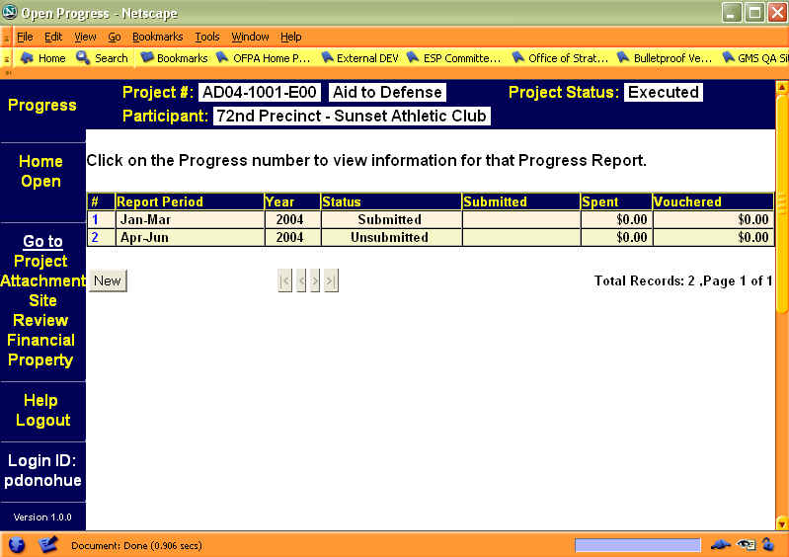
Figure 11: Initial Screen of the Progress Report Module,

The data in the Progress Report module’s sections (tabs) are:

Project Report Module’s Tabs
Tab | Information
General | Reporting Period, Reporting Year, Submission Date, Last Voucher Date, Progress Report Status, Final Report indicator, SAR Received Date, Total Amount Spent, Vouchered Amount, Person Submitting Report, and Remarks
Workplan Outcomes | The Project Goal, Objectives and Tasks are listed.

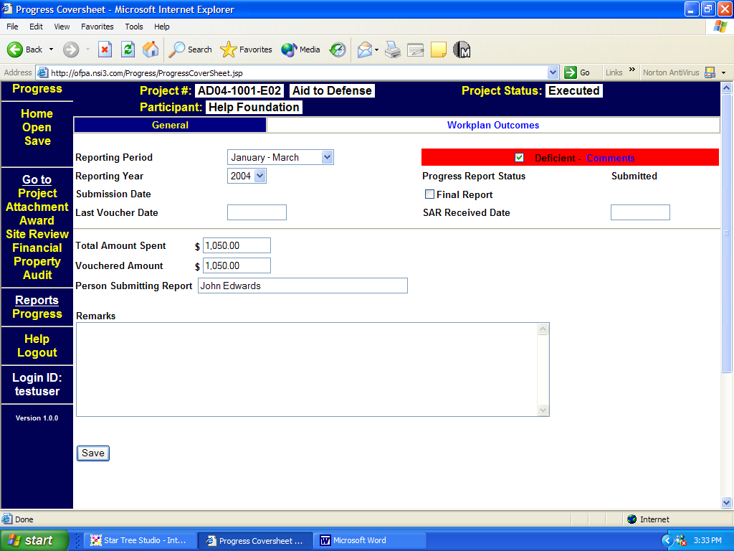
Figure 12: General Screen of the Progress Report Module

Creating a New Progress Report Record in GMS

To create a record of a Progress Report follow the steps below:
- Log in to the GMS.
- Click on Progress in the left frame of the GMS Welcome Screen.
- Click on the specific Project # (displayed in blue) from those listed.
- Click on New button at the bottom of the screen.
- Click the OK button on the dialog box to confirm the creation of a new progress report record.
- The General Tab will be displayed. Fill in the appropriate information. Click on the Save button at the bottom of the screen when all the information has been added. (Or click on Save on the left side of the screen.)
- Click on the Workplan Outcomes Tab. The Project Goal is at the top of the page followed by the Objectives and their associated Tasks. Under each Task is an Outcome area.
- To indicate the outcome for a specific task, click on the # under the Task. The next screen has the task at the top followed by text boxes to indicate Outcome Indicator and Unanticipated Outcome. Fill those out.
- Under Performance Measure record any values for the current quarter, the prior quarter and the value for year to date, if applicable. (Notice: that the value for year-to-date is not calculated by GMS)
- Click on the Save button at the bottom of the screen when all the information has been added. (Or click on Save on the left side of the screen.)
- When the information is complete, click on the Submit button in the left side frame of the screen.
  - Once the Progress Report is submitted, no changes may be made.
- Click the OK button on the dialog box to confirm that this progress report is to be submitted.

Editing a Progress Report in GMS

Only an unsubmitted progress report can be edited.

To edit a record of a Progress Report follow the steps below:
- Log in to the GMS.
- Click on Progress in the left frame of the GMS Welcome Screen.
- Click on the specific Project # (displayed in blue) from those listed.
- The General Tab will be displayed. Edit the information.
- Click on the Save button at the bottom of the screen when all the information has been added. (Or click on Save on the left side of the screen.)
- Click on the Workplan Outcomes Tab. The Project Goal is at the top of the page followed by the Objectives and their associated Tasks. Under each Task is an Outcome area. To edit the outcome for a specific task, click on the # under the Task. Edit the information.
- Click on the Save button at the bottom of the screen when all the information has been added. (Or click on Save on the left side of the screen.)
Site Review Report Module

The Site Review module of the GMS contains the documentation of official site visits made by OPDF personnel. A grantee can Read items in this module.

Accessing the Site Review Grid

To access the GMS Site Review module:
- Log in to the GMS.
- Click on the Site Review link on the left frame of the GMS Welcome page. The Site Review grid will then display on the right frame of the screen. (The sections of the screen are fully described in the GMS Navigation section, , on page 6)

Accessing a Specific Site Review Report

To access the record of Site Review Report for a specific project, follow the steps below:
- Log in to the GMS.
- Click on Site Review in the left frame of the GMS Welcome Screen.
- Click on the specific Project # (displayed in blue) from those listed. A list of the Site Review Reports for that project will then display in the right frame of the screen. If no Site Review Reports are displayed, that project does not have any Site Review reports recorded.
  - The data in the Site Review Report screen is presented in columns of information:
Site Review Column Definitions
Column Title | Definition
# | Sequential number for Site Review reports
Visit Date | The date the visit took place.
Visit Type | The type of visit report – site, telephone, desk audit, or blank.
Meeting Location | The place the meeting was held.

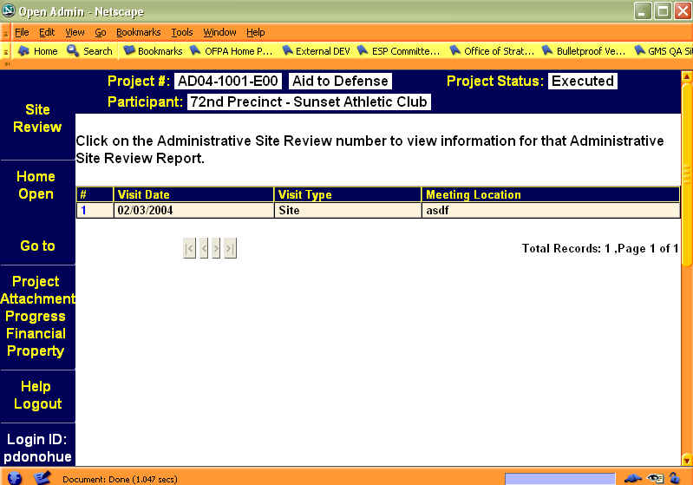
Figure 13 Site Review Screen

Viewing a Site Review Report Record in GMS

To view a Site Review Report follow the steps below:
- Log in to the GMS.
- Click on Site Review in the left frame of the GMS Welcome Screen.
- Click on the specific Project # (displayed in blue) from those listed.
- Select the Site Review to view (if the grid is empty, there are no Site Reviews associated with that Project).

  - The Site Review sections (tabs) are:
Site Review Tabs
Tab | Information
General | Last Voucher Date, Visit Type, Meeting Location, Attendees, Findings, Administrative Review Visit Persons.
Deficiency | #, Type Deficiency, Status, Comment

- The General Tab will be displayed. No edits will be allowed.

If necessary:
- Click on the Deficiency Tab, at the top of the page to view any deficiencies noted in the project during a Site Visit. No edits will be allowed.

Financial Report Module

The Financial module of the GMS collects a record of the Fiscal Cost Reports submitted by the grantee throughout the life cycle of the award.

Grantees can view information pertaining to the Fiscal Cost Reports associated with their project. The OPDF staff can view a grantee’s report. The OPDF financial staff may read, create and update information in this module.

Accessing the Financial Report Grid

To access the GMS Financial module:
- Log in to the GMS.
- Click on the Financial link on the left frame of the GMS Welcome page. The Financial grid will then display on the right frame of the screen. (The sections of the screen are fully described in the GMS Navigation section, on page 6.)

Accessing a Specific Fiscal Cost Report Record

To access the record of Financial Reports for a specific project, follow the steps below:
- Log in to the GMS.
- Click on Financial in the left frame of the GMS Welcome Screen.
- Click on the specific Project # (displayed in blue) from those listed. A list of the Fiscal Cost Reports for that project will then display in the right frame of the screen. If no Fiscal Cost Reports are displayed, that project does not have any reports recorded.
  - The data in the Financial Report screen is presented in columns of information:

Financial Module Initial Screen
Column Title | Definition
# | Sequential number for the fiscal cost reports
Report # | Number for financial record tracking
Received | Date that the report was received
Status | Whether the fiscal cost report has been submitted or not submitted.
Advance | The amount of money asked for
Expenditures DCJS | The amount of DCJS funds that have been spent.
Cash Requested | Amount of funds the grantee requested.

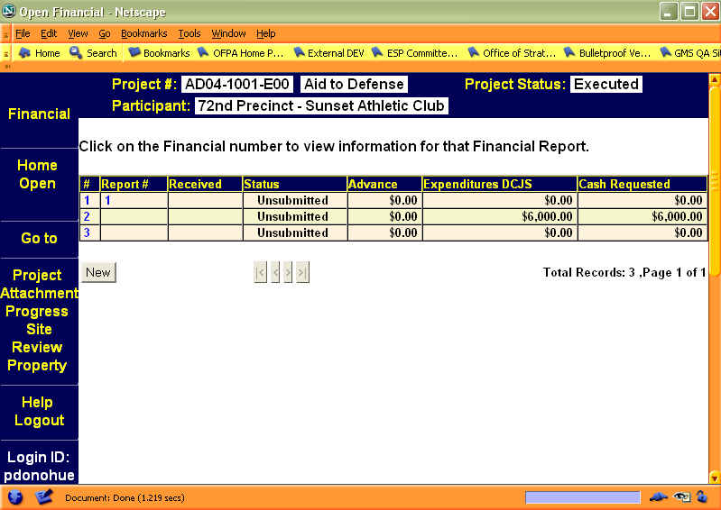
Figure 14 Initial Screen for the Financial Module

- To access a specific Financial Report Record, on the grid, click on the # or the Report # (both are displayed in blue). That Fiscal Cost Report will then display in the right frame of the screen.
  - The Financial module’s sections (tabs) are:

Financial Module Tabs
Tab | Information
General | Period covered by the report, whether or not there is any Deficiency, Financial Status, Submission Date, Received Date, Type of Report (quarterly, monthly, final or a blank), Advance Request, Expenditures for the Reporting Period and Comments.
Summary Schedule | The summarization of the expenditures by category. (see the next table)

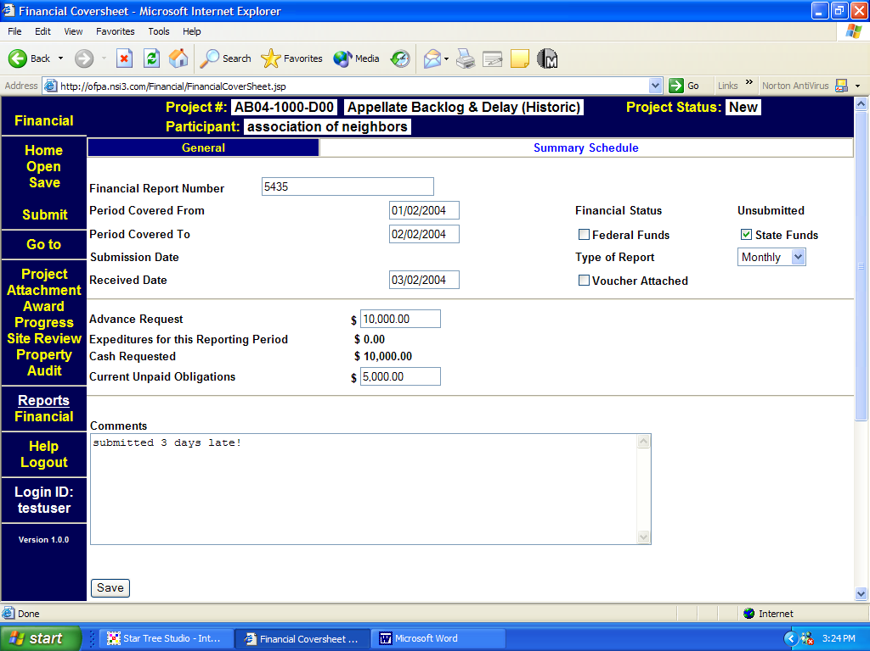
Figure 15 General Tab of the Financial Module

  - The Summary Schedule Tab displays information in five columns:
Summary Schedule Screen
Column Title | Definition
# | Sequential number.
Budget Category | The part of the budget in which the expenditure(s) were made.
A. Approved Project Budget | The approved budget as included in the Award Contract
B. Previous Cumulative Expenditures | Any expenditures recorded in previous electronic Fiscal Cost Reports
C. Expenditures for this Reporting period | Those expenditures recorded in the Summary Schedule entry screens for this Report
D. Current Cumulative Expenditures | The cumulative total of columns B and C.

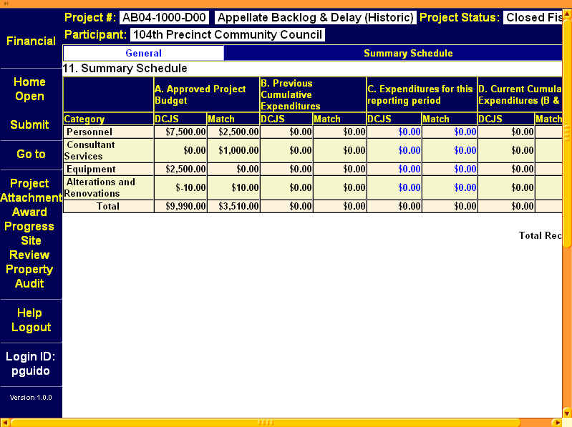
Figure 16: Summary Schedule of the Financial Module

Creating a New Fiscal Cost Report Record in GMS

To create a record of a Fiscal Cost Report follow the steps below:
- Log in to the GMS.
- Click on Financial in the left frame of the GMS Welcome Screen.
- Click on the specific Project # (displayed in blue) from those listed.
- Click on New button at the bottom of the screen.
- Click the OK button on the dialog box to confirm the creation of a new site review record.
- The General Tab will be displayed. Fill in the appropriate information.
- Click on the Save button at the bottom of the screen when all the information has been added. (Or click on Save on the left side of the screen.)
- Click on the Summary Schedule Tab.
- Click on the Column C Budget Category item (displayed in blue) that you wish to edit or add information to, and make your entries.
- Click on the Save button at the bottom of the screen when all the information has been added. (Or click on Save on the left side of the screen.)
- When you have completed your Fiscal Cost Report, click Submit in the left frame to finalize it. No edits will be allowed following a Submit.

Notice: Using the Submit button does not automatically transmit this report to DCJS. Because original signatures are required on Fiscal Cost Reports, you must print and mail 3 copies of the Fiscal Cost Report to DCJS.

Printing a Fiscal Cost Report for Mailing to DCJS

- From the Financial General screen, scroll down until you see Reports listed in white in the left frame.
- Choose the Financial Report by clicking on it; report opens in a new browser window.
- Use your browser's Print icon or FILE > Print to print a hardcopy of the Fiscal Cost Report
- Close the Report screen to return to the GMS Financial General screen.

Property Report Module

The Property Reports module contains reports of any purchased property or equipment associated with the grant funds (equipment is defined as durable [non-consumable] goods with a value of $100 or more).

Grantees can view, enter, submit and print an Equipment Inventory Report pertaining to grant funded property purchases associated with their project during the life of the grant. The OPDF staff can view a grantee’s property report.

Accessing the Property Reports Grid

To access the GMS Property Reports module:
- Log in to the GMS.
- Click on the Property link on the left frame of the GMS Welcome page. The Property Reports grid will then display on the right frame of the screen. (The sections of the screen are fully described in the GMS Navigation section, on page 6.)

Accessing Specific Property Reports

To access the record of Property Reports for a specific project, follow the steps below:
- Log in to the GMS.
- Click on Property in the left frame of the GMS Welcome Screen.
- Click on the specific Project # (displayed in blue) from those listed. A list of the Property Reports for that project will then display in the right frame of the screen. If no Property Reports are displayed, that project does not have any Property reports recorded.
  - The data in the Property Report Screen is presented in columns of information:

Property Reports Initial Screen
Column Title | Definition
# | Sequential number for the Property reports
Serial # | The serial number of the piece of property, if applicable.
Property Description | A description of the property.
Participant | Party that provided the funds for purchase of this piece of property.
Status | Whether the property is in active use, or has been disposed of.
Cost | The original cost of the property.
Delete | Allows user with the appropriate rights to delete the row.

- To access a specific Property Report Record, click on the # or the Serial # (displayed in blue). That Property Report will then display in the right frame of the screen.
  - The top part of the screen has text boxes for the property's/equipment's description, location, condition, etc.
  - The middle section has text boxes for the participant that provided the funds for purchase and text boxes for the serial, model and other ID numbers.
  - The bottom section has the information for property disposal and comments.

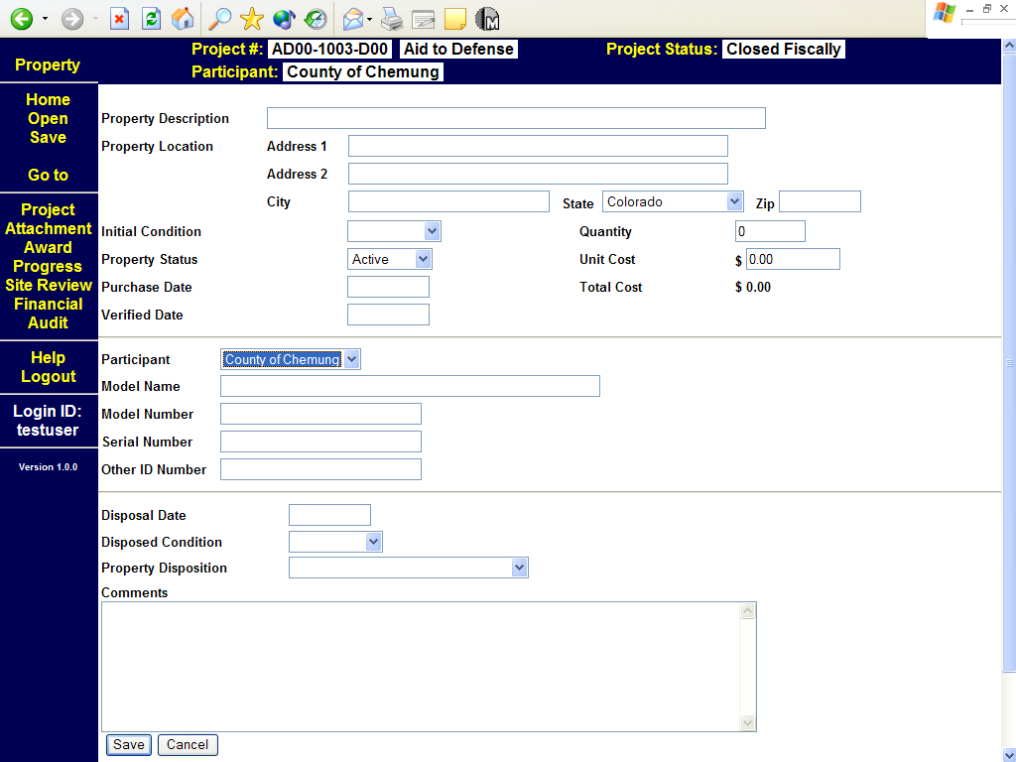
Figure 17: Property Module Form

Creating a New Property Report in GMS

To create a record of a Property Report follow the steps below:
- Log in to the GMS.
- Click on Property in the left frame of the GMS Welcome Screen.
- Click on the specific Project # (displayed in blue) from those listed.
- Click on New Property button at the bottom of the screen.
- The Property Description screen will be displayed. Fill in the appropriate information. Click on the Save button at the bottom of the screen when all the information has been added. (Or click on Save on the left side of the screen.)
- Repeat this process for each piece of property to be added.

Editing a Property Report in GMS

This process is used to provide the information on the disposal of the property, as well as changing any inaccurate information.

To edit a Property Report follow the steps below:
- Log in to the GMS.
- Click on Property in the left frame of the GMS Welcome Screen.
- Click on the specific Project # (displayed in blue) from those listed.
- The Property Description Screen will display.
- Click on the sequence # or Serial # (displayed in blue) to access a specific property.
- Edit the appropriate information.
- Click on the Save button at the bottom of the screen when all the information has been added. (Or click on Save on the left side of the screen.)

Notice: Because original signatures are required for Equipment Inventory Reports, you must print and mail your report to DCJS. User tip: Reports do not need to be printed and mailed for each piece of equipment purchased. It is suggested that reports be submitted quarterly or when all equipment purchases have been made, whichever comes first.

Printing an Equipment Inventory Report for Mailing to DCJS

- On the property Summary screen, click the PRINT button to the right of "New Property"

Reports

GMS provides a series of pre-constructed reports for grantee and OPDF use (note that these reports open a new browser window).

- Deficiency - A report displaying all fields in the application, with notations for those that have been flagged as 'deficient' by OPDF staff.

- Required Fields - Those fields required for successful submission of an application into GMS that are blank or incomplete; if the program finds incompletions, this report is automatically generated when the 'Submit' button is clicked.

- Application - A hard-copy version of the grant application that may be printed for filing.

- Contract - A brief report outlining the general information that is included in the grant contract, including its status - a 'snapshot' that may be printed for reference or filing.

- Award - The grant contract, may be printed for reference or review.

Glossary
Attachment Module | The GMS area that provides the ability for the grantee to upload any documentation that the grantee wishes to include with their submission.
Award | The allocation of State or federal grant funds to a particular grantee
OPDF | The DCJS Office of Program Development and Funding (State Administrative Agency for Federal criminal justice funding streams)
Budget | Fiscal information the grantee submits as a spending plan for the proposed project; later, the agreed-upon spending plan for the project as incorporated into the contract.
Budget Version | GMS allows the grantee to enter multiple budgets for a project. For example, a collaborative project undertaken by a consortium of agencies might make it necessary for a grantee to enter the budget for each agency (participant) separately. Each budget is a separate version.
Contacts | Those individuals associated with a grant-funded project who have specific duties; those individuals with who OPDF staff would need to interact during the course of a grant contract (see Primary, Fiscal, Signatory, Alternate).
Contract | A binding agreement between NYS and a grantee for the sub-award of State or Federal grant funds
Contract number | A OPDF-assigned number that identifies a grant contract.
DCJS number | A OPDF-assigned number that identifies a grant award; includes the Funding Program, Funding Year, and contract number.
Deficiency/Deficient | An area in an application or progress report that OPDF staff have determined is incomplete or requires revision before an application can be approved, a contract written, or a progress report accepted.
Financial Module | The GMS area that captures a record of the Fiscal Cost Reports submitted by the grantee throughout the life cycle of the award.
Fiscal Contact | Individual primarily responsible for the Fiscal record keeping and reporting associated with a grant-funded project.
Funding program | A particular source of State or Federal Funding (e.g., Violence Against Women - funds allocated to address domestic violence issues by the federal Office of Violence Against Women; indicated by funding program code 'VW').
GMS | Grants Management System; an electronic Web-based application that allows a user to enter, view and maintain data stored in an Oracle Database.
Grantee | A municipality, unit of government or not-for-profit organization that has received State or Federal criminal justice funding through OPDF
Implementing Agency | The agency (ies) or entity (ies) that will carry out the tasks outlined in the award contract Appendix D - Project Work Plan
Outcomes | The end-result of activities undertaken to accomplish the objectives and tasks (e.g., number of clients served, a narrative description of a task in progress, a narrative explanation of a delay in completing a task).
Participant | An agency involved in conducting the business of a grant-funded Project; Grantee and/or Implementing Agency.
Performance measure | The yardstick by which a grantee will measure its performance in accomplishing project objectives and tasks.
Primary Contact | Individual who has principal responsibility for the operation of a grant-funded project.
Program Representative | The OPDF staff person with primary responsibility for a particular grant contract
Progress Report Module | The GMS area that captures progress report information submitted by the grantee during the length of the project.
Project | A specific activity to be supported by State or Federal grant funds; in GMS, the collective information about an activity, including applicant agency, work plan, budget, etc.
Project Module | The GMS area that captures the information that is provided by an applicant when requesting funds as part of a grant application.
Project number | A GMS System-assigned number that identifies a Project; includes Funding Program and calendar year.
Property Module | The GMS area that captures data on property or equipment purchased with grant funds (equipment is defined as durable [non-consumable] goods with a value of $100 or more). Inventory.
Questions | Program-Specific Questions; under most funding programs, OPDF requires information on specific issues in order to consider an application for funding; the Questions area is designed to solicit that information.
Save | In GMS, a function that allows you to secure data you have already entered. Does not transmit data to OPDF.
Signatory Contact | Individual with signing authority for a grantee agency; signs a grant contract on behalf of the grantee agency or entity.
Site Review Module | The GMS area that documents official site visits made by OPDF personnel.
Submit | In GMS, the function that transmits entered data to OPDF. Following a submit, edits by the grantee are no longer possible.
Tab | In GMS, a series of hyperlinked graphics across the top of a screen, analogous to the tabs in a 3-ring binder; enables easy navigation.
Unanticipated outcome | A result of activities that was unexpected and not considered in the creation of objectives and tasks for the workplan.
Work Plan | The Goals, Tasks and Objectives that make up a grant-funded project; those activities the Grantee agrees to complete in the contract.

